**A SUMMER INTERNSHIP REPORT ON**

**NX SOFTWARE**

**IN**

**MECHANICAL ENGINEERING**

**BY**

**T. KALYAN 21KD5A0318**



**Department of Mechanical Engineering**

**LENDI INSTITUTE OF ENGINEERING AND TECHNOLOGY**

**An Autonomous Institution**

**Permanently Affiliated to JNTUGV Vizianagaram,**

**Approved by AICTE Accredited by NBA and NAAC with ‘A’ Grade**

**JONNADA VILLAGE, DENKADA MANDAL,**

**VIZIANAGARAM DISTRICT, ANDHRA PRADESH,**

**INDIA-535005**

**2021-2024**

**SIGNATURE OF GUIDE**

**SIGNATURE OF HOD**



**LENDI INSTITUTE OF ENGINEERING AND TECHNOLOGY**

**An Autonomous Institution Permanently Affiliated to JNTUGV Vizianagaram,**

**Approved by AICTE Accredited by NBA and NAAC with ‘A’ Grade**

**JONNADA VILLAGE, DENKADA MANDAL,**

**VIZIANAGARAM DISTRICT, ANDHRA PRADESH,**

**INDIA-535005**

**ACKNOWLEDGEMENT**

We take this opportunity to express sincere gratitude to our guide, Mr.G. Ravi, MTech, Assistant Professor, Department of Mechanical Engineering, Lendi Institute of Engineering and Technology, Jonnada (V), Vizianagaram (Dist), for rendering us valuable advice always. He has been the perennial source of inspiration and motivation right from the inception for completion of the summer internship.

We are indeed very grateful to Dr. Satish Pujari, M. Tech, Ph. D, Head of the Department of Mechanical Engineering, for his valuable suggestions and guidance to us right from the beginning of our summer internship.

With a great sense of pleasure and privilege, we extend our gratitude to

Dr.V.V Rama Reddy, Principal, LIET, Jonnada (V), Vizianagaram (Dist).

We sincerely thank IGIAT team for giving us their heartful support in all the stages of the summer internship and completion of the summer internship.

We sincerely thank all the staff members of the department for giving us their heartful support in all the stages of the project work and completion of the summer internship.

**T. KALYAN 21KD1A0318**



**LENDI INSTITUTE OF ENGINEERING AND TECHNOLOGY**

**An Autonomous Institution Permanently Affiliated to JNTUGV Vizianagaram,**

**Approved by AICTE Accredited by NBA and NAAC with ‘A’ Grade**

**JONNADA VILLAGE, DENKADA MANDAL,**

**VIZIANAGARAM DISTRICT, ANDHRA PRADESH,**

**INDIA-535005**

**INSTITUTE VISION AND MISSION**

# VISION

Producing globally competent and quality technocrats with

human values for the holistic needs of industry and society.

# MISSION

* Creating an outstanding infrastructure and platform for enhancement of skills, knowledge and behaviour of students towards employment and higher studies.
* Providing a healthy environment for research, development and entrepreneurship to meet the expectations of industry and society.
* Transforming the graduates to contribute to the socio-economic development and welfare of the society through value-based education.



**LENDI INSTITUTE OF ENGINEERING AND TECHNOLOGY**

**An Autonomous Institution Permanently Affiliated to JNTUGV Vizianagaram,**

**Approved by AICTE Accredited by NBA and NAAC with ‘A’ Grade**

**JONNADA VILLAGE, DENKADA MANDAL,**

**VIZIANAGARAM DISTRICT, ANDHRA PRADESH,**

**INDIA-535005**

**DEPARTMENT OF MECHANICAL ENGINEERING**

# VISION

Envisions mechanical engineers of highly competent and skilled professionals to meet the needs of the modem society.

# MISSION

* Providing a conducive and inspiring learning environment to become competent engineers.
* Providing additional skills and training to meet the current and future needs of the industry.
* Providing a unique environment towards entrepreneurship by fostering innovation, creativity, freedom and empowerment.



**LENDI INSTITUTE OF ENGINEERING AND TECHNOLOGY**

**An Autonomous Institution Permanently Affiliated to JNTUGV Vizianagaram,**

**Approved by AICTE Accredited by NBA and NAAC with ‘A’ Grade**

**JONNADA VILLAGE, DENKADA MANDAL,**

**VIZIANAGARAM DISTRICT, ANDHRA PRADESH,**

**INDIA-535005**

## **PROGRAM EDUCATIONAL OBJECTIVES (PEOs)**

* **PEO1:** Graduates will have strong knowledge, skills and attitude towards employment, higher studies and research.

* **PEO2:** Graduates shall comprehend latest tools and techniques to analyze, design and develop novel systems and products for real life problems.

* **PEO3:** Graduates shall have multidisciplinary approach, professional attitude, ethics, good communication, teamwork and engage in lifelong learning to adapt the rapidly changing technologies.



**LENDI INSTITUTE OF ENGINEERING AND TECHNOLOGY**

**An Autonomous Institution Permanently Affiliated to JNTUGV Vizianagaram,**

**Approved by AICTE Accredited by NBA and NAAC with ‘A’ Grade**

**JONNADA VILLAGE, DENKADA MANDAL,**

**VIZIANAGARAM DISTRICT, ANDHRA PRADESH,**

**INDIA-535005**

## **PROGRAM OUTCOMES (POs)**

**PO1 Engineering knowledge:** Apply the knowledge of mathematics, science, engineering fundamentals, and an engineering specialization to the solution of complex engineering problems.

**PO2 Problem analysis:** Identify, formulate, review research literature, and analyse complex engineering problems reaching substantiated conclusions using first principles of mathematics, natural sciences, and engineering sciences.

**PO3 Design/development of solutions:** Design solutions for complex engineering problems and design system components or processes that meet the specified needs with appropriate consideration for the public health and safety, and the cultural, societal, and environmental considerations.

**PO4 Conduct investigations of complex problems:** Use research-based knowledge and research methods including design of experiments, analysis and interpretation of data, and synthesis of the information to provide valid conclusions.

**PO5 Modern tool usage:** Create, select, and apply appropriate techniques, resources, and modern engineering and IT tools including prediction and modelling to complex engineering activities with an understanding of the limitations.

**PO6 The engineer and society:** Apply reasoning informed by the contextual knowledge to assess societal, health, safety, legal and cultural issues and the consequent responsibilities relevant to the professional engineering practice.

**PO7 Environment and sustainability:** Understand the impact of the professional engineering solutions in societal and environmental contexts, and demonstrate the knowledge of, and need for sustainable development.

**PO8 Ethics:** Apply ethical principles and commit to professional ethics and responsibilities and norms of the engineering practice.

**PO9 Individual and teamwork:** Function effectively as an individual, and as a member or leader in diverse teams, and in multidisciplinary settings.

**PO10 Communication:** Communicate effectively on complex engineering activities with the engineering community and with society at large, such as, being able to comprehend and write effective reports and design documentation, make effective presentations, and give and receive clear instructions.

**PO11 Project management and finance**: Demonstrate knowledge and understanding of the engineering and management principles and apply these to one’s own work, as a member and leader in a team, to manage projects and in multidisciplinary environments.

**PO12 Life-long learning:** Recognize the need for and have the preparation and ability to engage in independent and life-long learning in the broadest context of technological change.

## **PROGRAM SPECIFIC OUTCOMES (PSOs)**

* **PSO1:** Capable of design, develop and implement sustainable mechanical and environmental systems.

* **PSO2:** Qualify in national and international competitive examinations for successful higher studies and employment.

**LENDI INSTITUTE OF ENGINEERING AND TECHNOLOGY(A)**

(Approved by A.I.C.T.E & Permanently Affiliated to JNTUG, Vizianagaram)

***Accredited by NBA & NAAC with ‘A’ Grade***

**Jonnada (Village), Denkada (Mandal), Vizianagaram Dist. – 535 005.**

**Phone No. 08922-241111, 241112**

[**E-Mail.: lendi_2008@yahoo.com Website**](mailto:lendi_2008@yahoo.comWebsite)[**:www.lendi.org**](http://www.lendi.org/)

**CERTIFICATE**

This is to certify that the project report entitled **ROBOTIC ARM** is being submitted by

**T. KALYAN 21KD5A0318**

In partial fulfilment of Project in Mechanical Engineering to the Jawaharlal Nehru Technological University, Vizianagaram is a record of Bonafede work carried out under my guidance and supervision.

The results embodied in this project report have not been submitted to any other Institute or University.

**SIGNATURE OF THE GUIDE SIGNATURE OF HOD**

**STUDENT ATTESTATTION**

STUDENT ATTESTATTION This is certifying that; I have personally worked on the dissertation entitled” **ROBOTIC ARM**”. A data mentioned in this report was obtained during genuine work done and collected by me.

**T. KALYAN 21KD5A0318**

**DATE: __/ __ /__ PLACE: JONADA**

**CONTENTS**

**CHAPTER1:** INTRODUTION OF NX10……………. 1-13

* 1. INTRODUTION OF NX10
  2. STARTING AN NX 10 SESSION AND OPENING
  3. FILES START AN NX 10 SESSION
  4. NX 10 GATEWAY
  5. RIBBON BAR
  6. QUICK ACCESS TOOLBAR
  7. COMMAND FINDER
  8. PART NAVIGATOR
  9. GEOMETRY SELECTION
  10. FEATURE SELECTION
  11. USER PREFERENCES
  12. USER INTERFACE
  13. VISUALIZATION
  14. APPLICATIONS
  15. COORDINATE SYSTEMS
  16. ABSOLUTE COORDINATE SYSTEM
  17. WORK COORDINATE SYSTEM
  18. TOOLBARS
  19. TWO DIMENSIONAL SKETCHING
  20. OVERVIEW

**CHAPTETR 2**: TWO DIMENSIONAL SKETCHING……..14-20

* 1. TWO DIMENSIONAL SKETCHING
  2. SKETCHING ENVIRONMENT
  3. SKETCH CURVE TOOLBAR
  4. PROFILE
  5. LINE
  6. ARC
  7. CIRCLE
  8. QUICK TRIM
  9. STUDIO SPLINE
  10. CONSTRAINTS TOOLBAR
  11. DIMENSIONAL CONSTRAINTS
  12. GEOMETRIC CONSTRAINTS
  13. DISPLAY SKETCH CONSTRAINTS

2.14 SHOW/REMOVE CONSTRAINTS

**CHAPTER 3**: THREE DIMENSIONAL MODELING………..21-29

* 1. THREE DIMENSIONAL MODELING
  2. TYPES OF FEATURES
  3. PRIMITIVES
  4. DATUM AXIS
  5. GENERAL HOLE
  6. FEATURE OPERATIONS
  7. EDGE BLEND
  8. CHAMFER
  9. THREAD
  10. MIRROR
  11. PATTERN
  12. BOOLEAN OPERATIONS:
  13. UNITE
  14. SUBTRACT
  15. INTERSECT
  16. MOVE

**CHAPTER 4:** ASSEMBLY MODELING …………………30-31

4.1 ASSEMBLY MODELING

* 1. MATING CONSTRAINTS

**CHAPTER 5:** PROJECT……………………………………32-45

* 1. AIM
  2. TOOLS USED FOR SKETCHING
  3. TOOLS USED FOR ASSEMBLY
  4. TOOLS USED FOR DRAFTING
  5. MODEL 1
  6. MODEL 2
  7. MODEL 3
  8. MODEL 4
  9. ASSEMBLE THE COMPONENTS

1. CONCLUSION

**1. INTRODUTION OF NX10**

**1.1 INTRODUTION OF NX10:**

The modern manufacturing environment can be characterized by the paradigm of delivering products of increasing variety, smaller batches and higher quality in the context of increasing global competition. Industries cannot survive worldwide competition unless they introduce new products with better quality, at lower costs and with shorter lead-time. There is intense international competition and decreased availability of skilled labour. With dramatic changes in computing power and wider availability of software tools for design and production, engineers are now using Computer Aided Design (CAD), Computer Aided Manufacturing (CAM) and Computer Aided Engineering (CAE) systems to automate their design and production processes. These technologies are now used every day for sorts of different engineering tasks. Below is a brief description of how CAD, CAM, and CAE technologies are being used during the product realization process.

**1.2 STARTING AN NX 10 SESSION AND OPENING FILES START AN NX 10 SESSION:**

* From the Windows desktop screen, click on Start →All Programs →Siemens NX 10 → NX 10
* USER INTERFACCE OF NX: he main NX 10 Screen will open. This is the Gateway for the NX 10 software. The NX 10 blank screen looks like the figure shown below. There will be several tips displayed on the screen about the special features of the current version.

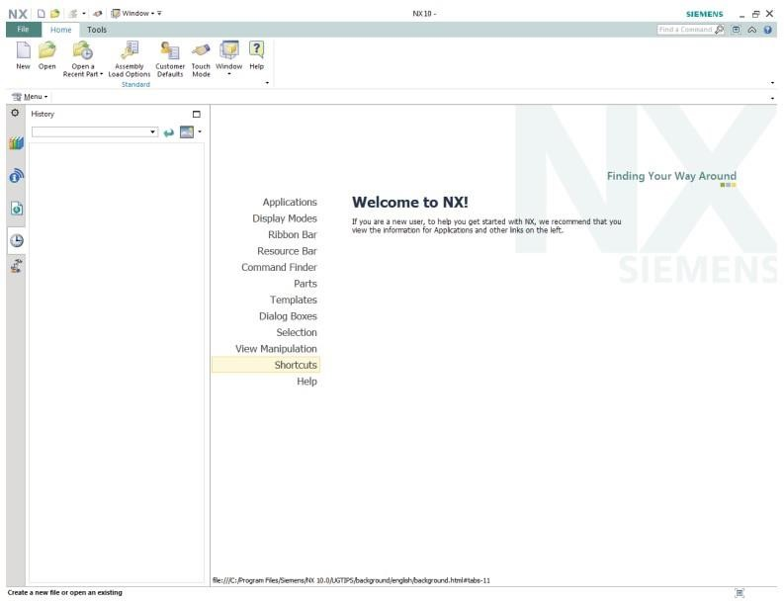

**1.3 NX 10 GATEWAY:**

The following figure shows the typical layout of the NX 10 window when a file is opened. This is the Gateway of NX 10 from where you can select any module to work on such as modelling, manufacturing, etc. It has to be noted that these toolbars may not be exactly on the same position of the screen as shown below. The toolbars can be placed at any location or position on the screen. Look out for the same set of icons.

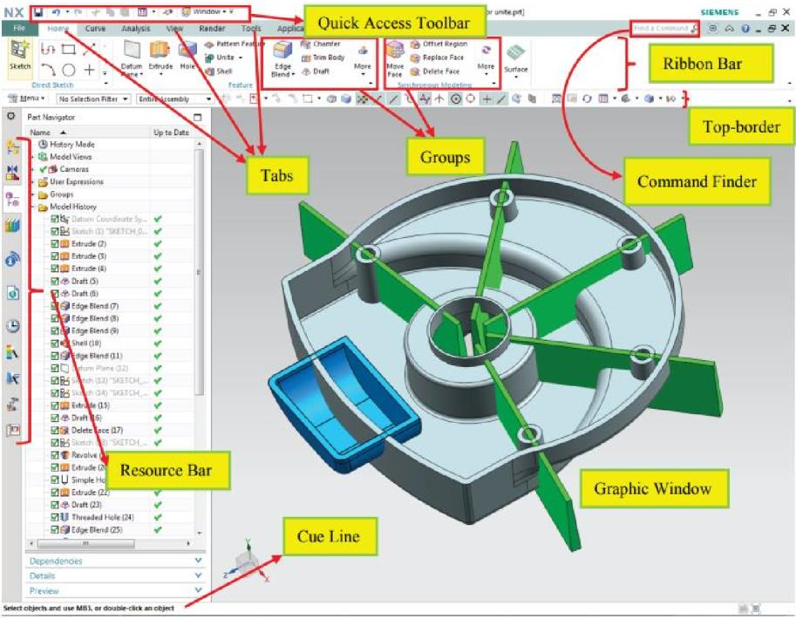

1.4 **RIBBON BAR:**

The ribbon bar interface gives the user the ability to access the different commands easily without reducing the graphics window area. Commands are organized in ribbon bars under different tabs and groups for easy recognition and accessibility.

1.5 **QUICK ACCESS TOOLBAR:**

The quick access toolbar has most commonly used buttons (save, undo, redo, cut, copy, paste and recent commands) to expedite the modelling process. You may easily customize these buttons as shown in the figure below.

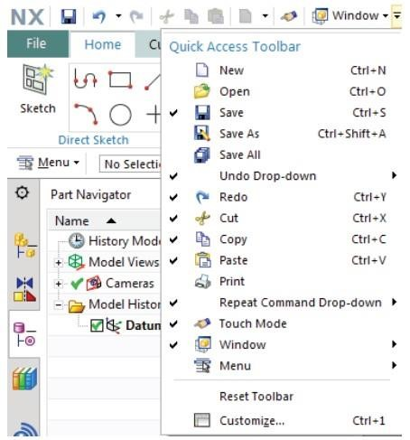

**1.6** **COMMAND FINDER:**

If you do not know where to find a command, use Command Finder. Let’s say we have forgotten where the Styled Sweep is.

* Type sweep in the Command Finder
* Hover the mouse over Styled Sweep
* NX will show you the path to the command: Menu →Insert →Sweep →Styled Sweep
* Click on Styled Sweep in the Command Finder window

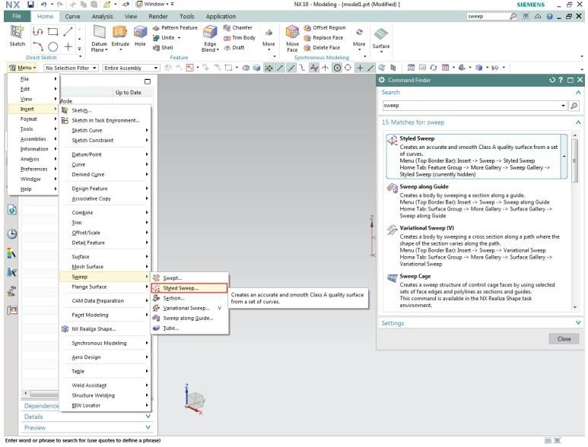

**1.7 PART NAVIGATOR:**

Click on the **Part Navigator icon**, the third icon from the top on the **Resource bar**

The Part Navigator provides a visual representation of the parent-child relationships of features in the work part in a separate window in a tree type format. It shows all the primitives, entities used during modelling. It allows you to perform various editing actions on those features. For example, you can use the Part Navigator to Suppress or Un suppress the features or change their parameters or positioning dimensions. Removing the green tick mark will ‘Suppress’ the feature. The software will give a warning if the parent child relationship is broken by suppressing any particular feature. The Part Navigator is available for all NX applications and not just for modelling. However, you can only perform feature editing operations when you are in the Modelling module. Editing a feature in the Part Navigator will automatically update the model.

Feature editing will be discussed later.

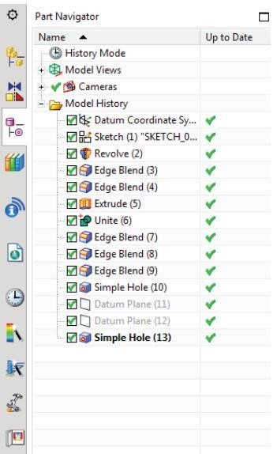

**1.8 GEOMETRY SELECTION:**

You can filter the selection method, which facilitates easy selection of the geometry in a close cluster. In addition, you can perform any of the feature operation options that NX 10 intelligently provides depending on the selected entity. Selection of items can be based on the degree of the entity like, selection of Geometric entities, Features and Components. The selection method can be opted by choosing one of the icons in the Selection Toolbar.

**1.9 FEATURE SELECTION:**

Clicking on any of the icons lets you select the features in the part file. It will not select the basic entities like edges, faces etc. The features selected can also be applied to a part or an entire assembly depending upon the requirement.

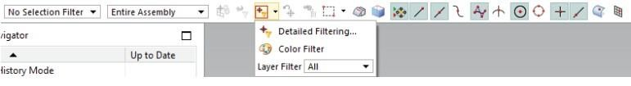

**1.10 USER PREFERENCES:**

Choose Preferences on the Menu button (located to top left of the main window) to find the various options available

User Preferences are used to define the display parameters of new objects, names, layouts, and views. You can set the layer, colour, font, and width of created objects. You can also design layouts and views, control the display of object and view names and borders, change the size of the selection ball, specify the selection rectangle method, set chaining tolerance and method, and design and activate a grid. Changes that you make using the Preferences menu override any counterpart customer defaults for the same functions.

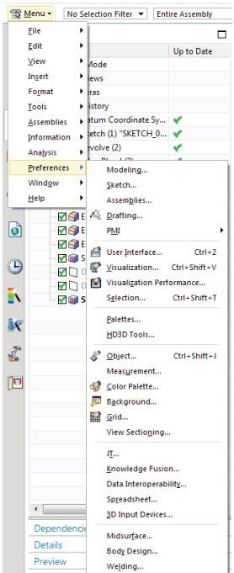

**1.11 USER INTERFACE:**

* Choose Preferences →User Interface to find the options in the dialog box
* The User Interface option customizes how NX works and interacts to specifications you set. You can control the location, size and visibility status of the main window, graphics display, and information window. You can set the number of decimal places (precision) that the system uses for both input text fields and data displayed in the information window. You can also specify a full or small dialog for file selection. You can also set macro options and enable a confirmation dialog for Undo operations
* The Layout tab allows you to select the User Interface Environment
* The Touch tab lets you use touch screens
* The Options tab allows you, among others, to set the precision level (in the Information Window)
* The Journal tab in the Tools allows you to use several programming languages
* The Macro tab in the Tools allows you to set the pause while displaying animation

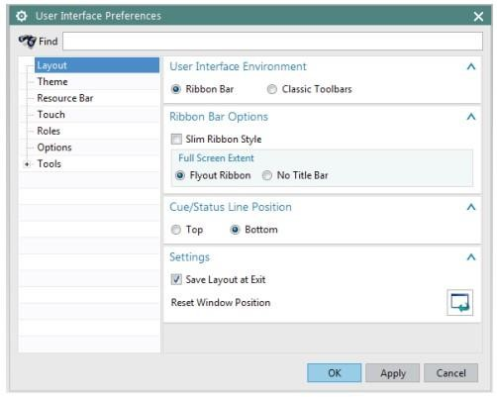

**1.12 VISUALIZATION:**

Choose Preferences →Visualization to find the options in the dialog box

This dialog box controls attributes that affect the display in the graphics window.

Some attributes are associated with the part or with particular Views of the part. The settings for these attributes are saved in the part file. For many of these attributes, when a new part or a view is created, the setting is initialized to the value specified in the Customer Defaults file. Other attributes are associated with the session and apply to all parts in the session. The settings of some of these attributes are saved from session to session in the registry. For some session attributes, the setting can be initialized to the value specified by customer default, an environment variable.

* Choose Preferences →Colour Pallet to find the options in the dialog box

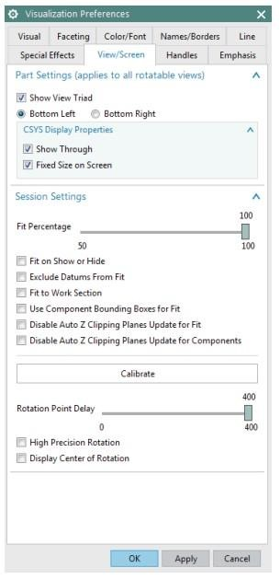

Click on Preferences →Background to get another pop up Dialog box.

You can change your background colour whatever you want The background colour refers to the colour of the background of the graphics window. NX supports graduated backgrounds for all display modes. You can select background colours for Shaded or Wireframe displays. The background can be Plain or Graduated. Valid options for all background colours are 0 to 255. You can change and observe the Colour and Translucency of objects.

Click Preferences →Object

This will pop up a dialog window Object Preferences. You can also apply this setting to individual entities of the solid. For example, you can click on any particular surface of the solid and apply the Display settings.

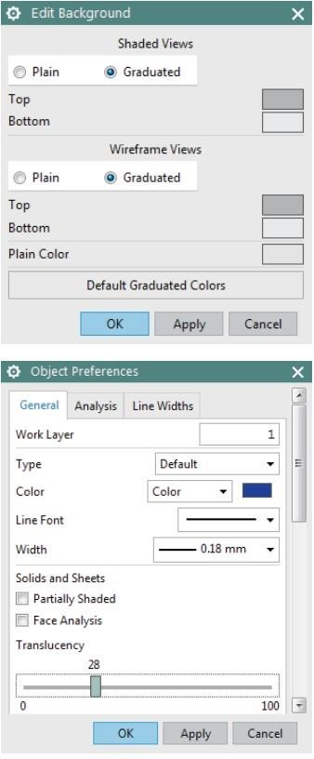

**1.13 APPLICATIONS:**

Applications can be opened using the File option located at the top left corner of the main window OR the Applications tab above the Ribbon bar. You can select the type of application you want to run. For example, you can select Modelling, Drafting, Assembly, and so on as shown in the figure. The default Application that starts when you open a file or start a new file is Modelling. We will introduce some of these Application in the next chapters.

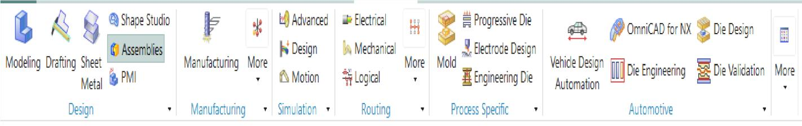

**1.14 COORDINATE SYSTEMS:**

There are different coordinate systems in NX. A three-axis symbol is used to identify the coordinate system.

**1.15 ABSOLUTE COORDINATE SYSTEM:**

The Absolute Coordinate System is the coordinate system from which all objects are referenced. This is a fixed coordinate system and the locations and orientations of every object in NX 10 modeling space are related back to this system. The Absolute Coordinate System (or Absolute CSYS) also provides a common frame of reference between part files. An absolute position at X=1, Y=1, and Z=1 in one part file is the same location in any other part file.

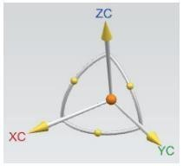

The View Triad on the bottom-left of the Graphics window is ONLY a visual indicator that represents the ORIENTATION of the Absolute Coordinate System of the model.

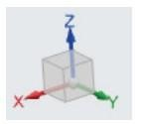

**1.16 WORK COORDINATE SYSTEM:**

The Work Coordinate System (WCS) is what you will use for construction when you want to determine orientations and angles of features. The axes of the WCS are denoted XC, YC, and ZC. (The “C” stands for “current”). It is possible to have multiple coordinate systems in a part file, but only one of them can be the work coordinate system.

**1.17 TOOLBARS:**

Toolbars contain icons, which serve as shortcuts for many functions. The figure on the right shows the main Toolbar items normally displayed. However, you can find many more icons for different feature commands, based on the module selected and how the module is customized.

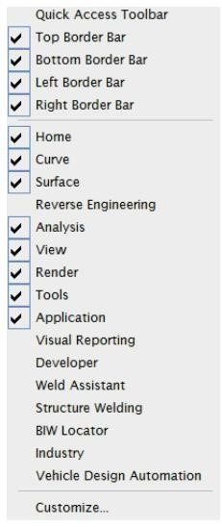

* Right-Clicking anywhere on the existing toolbars gives a list of other Toolbars. You can add any of the toolbars by checking them.

Normally, the default setting should be sufficient for most operations but during certain operations, you might need additional toolbars. If you want to add buttons pertaining to the commands and toolbars,

* Click on the pull-down arrow on any of the Toolbars and choose Customize.

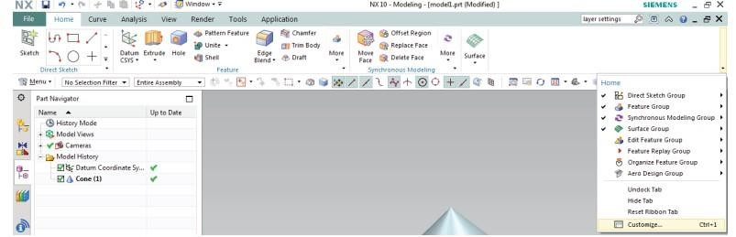

This will pop up a Customize dialog window with all the Toolbars and commands pertaining to each Toolbar under Commands tab. To add a command,

* Choose a category and drag the command from the Commands list to the desired location.

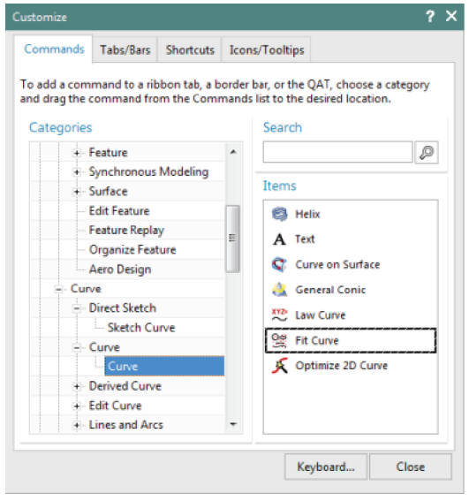

**1.18 TWO DIMENSIONAL SKETCHING:**

In most cases, Modelling starts from a 2D sketch and then Extrude, Revolve or Sweep the sketch to create solids. Many complex shapes that are otherwise very difficult to model can easily be drawn by sketching. In this chapter, we will see some concepts of sketching and then proceed to sketch and model some parts.

**1.19 OVERVIEW:**

An NX 10 sketch is a named set of curves joined in a string that when swept, form a solid. The sketch represents the outer boundary of that part. The curves are created on a plane in the sketcher. In the beginning, these curves are drawn without any exact dimensions. Then,

Dimensional Constraints as well as Geometric Constraints are applied to fully constrain the sketch.

After sketching is completed, there are different ways to use them to generate 3D parts:

* A sketch can be revolved

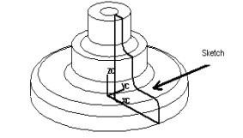

* A sketch can be extruded

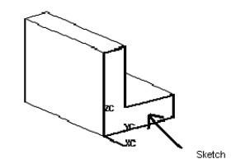

* A sketch can be swept along a guide (line):

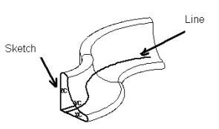

**2: TWO DIMENSIONAL SKETCHING**

**2.1 SKETCHING ENVIRONMENT**

In NX 10 you can create sketch using two ways. The first method creates the

Sketch in the current environment and application. For this  Choose Menu →Insert →Sketch

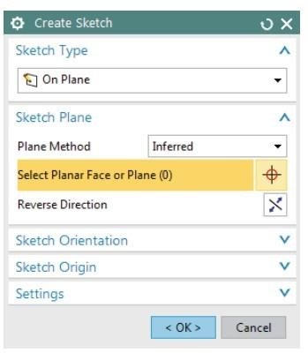

In the other method you can create Sketch using

* + Choose Sketch in Home toolbar

In either case, a dialog box pop-ups asking you to define the Sketch Plane. The screen will display the sketch options. You can choose the Sketch Plane, direction of sketching and type of plane for sketching. When you create a sketch using the Create Sketch dialog box, you can choose the plane on which the sketch can be created by clicking on the coordinate frame as shown. This will highlight the plane you have selected. The default plane selected is XC-YC. However, you can choose to sketch on another plane. If there are any solid features created in the model beforehand, any of the flat surfaces can also be used as a sketching plane.

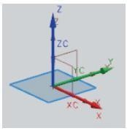

* Choose the XC-YC plane and click OK

The sketch plane will appear and the X-Y directions will be marked.

The main screen will change to the Sketching Environment. The XY plane is highlighted as the default plane for sketching. This is the basic sketch window. There is also a special Sketch Task Environment in NX 10 which displays all sketch tools in the main window. For accessing the Sketch Task Environment,

* + Click the More option in the direct sketch tool bar area
  + Click on Open in Sketch Task Environment as shown below

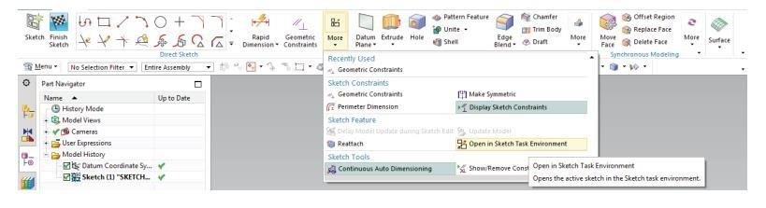

There are three useful options next to the Finish Flag. You can change the name of the sketch in the box. The next one is Orient to Sketch which orients the view to the plane of the sketch. If the model file is rotated during the process of sketching,

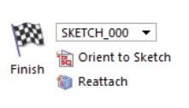

click on this icon to view the sketch on a plane parallel to the screen Reattach attaches the sketch to a different planar face, datum plane, or path, or changes the sketch orientation. It allows you to reattach the sketch to the desired plane without recreating all the curves, dimensions, and constraints.

**2.2 SKETCH CURVE TOOLBAR:**

This toolbar contains icons for creating the common types of curves and spline curves, editing, extending, trimming, filleting etc.

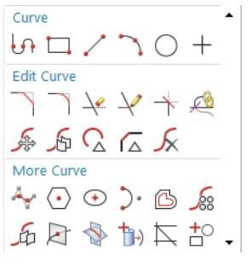

Each type of curve has different methods of selection and methods of creation. Let us discuss the most frequently used options.

**2.3 PROFILE:**

This option creates both straight lines as well as arcs depending on the icon you select in the popup toolbar. You can pick the points by using the coordinate system or by entering the length and angle of the line as shown in the following figures.

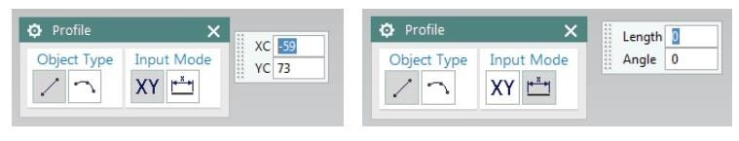

**2.4 LINE:**

This option will selectively create only straight lines.

**2.5 ARC:**

This option creates arcs by either of two methods. The first option creates arc with three sequential points as shown below.

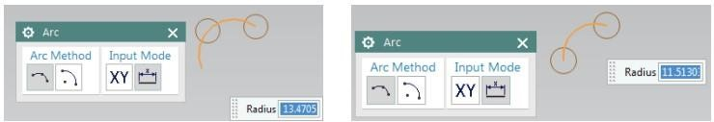

The second option creates the arc with a centre point, radius and sweep angle or by centre point with a start point and end point. The illustration is shown below.

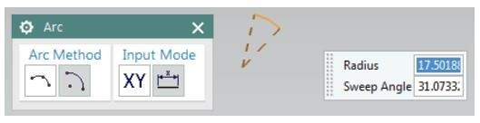

**2.6 CIRCLE:**

Creating a circle is similar to creating an arc, except that circle is closed.

**2.7 QUICK TRIM:**

This trims the extending curves from the points of intersection of the curves. This option reads every entity by splitting them if they are intersected by another entity and erases the portion selected.

**2.8 STUDIO SPLINE:**

You can create basic spline curves (B-spline and Bezier) with poles or through points with the desired degree of the curve. The spline will be discussed in detail in the seventh chapter (Freeform Features).

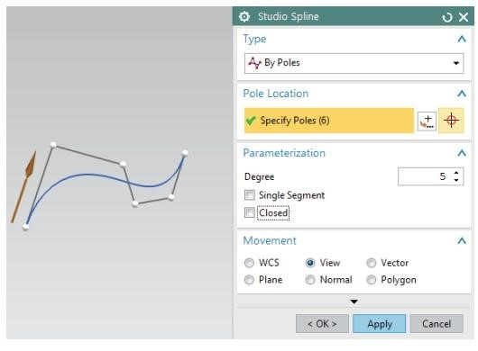

**2.9 CONSTRAINTS TOOLBAR:**

All the curves are created by picking points. For example, a straight line is created with two points. In a 2D environment, any point has two degrees of freedom, one along X and another along Y axis. The number of points depends on the type of curve being created. Therefore, a curve entity has twice the number of degrees of freedom than the number of points it comprises. These degrees of freedom can be removed by creating a constraint with a fixed entity. In fact, it is recommended that you remove all these degrees of freedom (making the sketch Fully Constrained) by relating the entities directly or indirectly to the fixed entities. It can be done by giving dimensional or geometric properties like Parallelity, Perpendicularity, etc.

In NX 10 smart constraints are applied automatically, i.e. automatic dimensions or geometrical constraints are interpreted by NX 10. You can turn this option off by clicking on Continuous Auto Dimensioning as shown below. The following paragraphs show how to manually apply constraints.

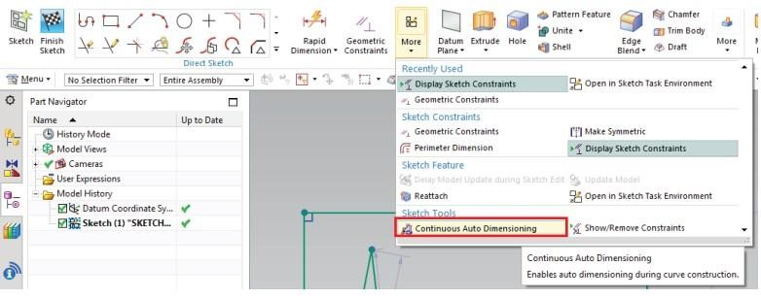

**2.10 DIMENSIONAL CONSTRAINTS:**

The degrees of freedom can be eliminated by giving dimensions with fixed entities like axes, planes, the coordinate system or any existing solid geometries created in the model. These dimensions can be linear, radial, angular etc. You can edit the dimensional values at any time during sketching by double-clicking on the dimension.

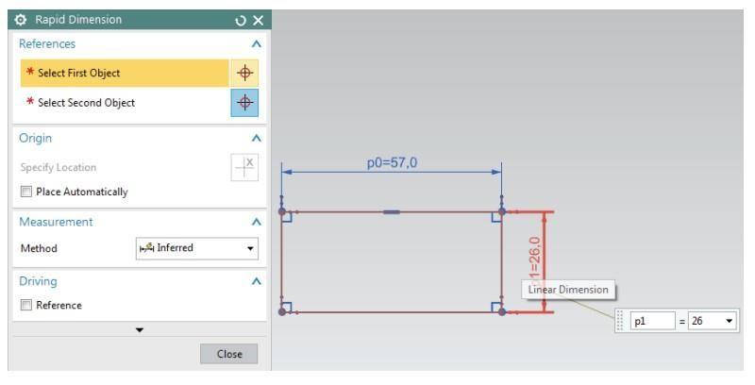

**2.11 GEOMETRIC CONSTRAINTS:**

Besides the dimensional constraints, some geometric constraints can be given to eliminate the degrees of freedom. They include parallel, perpendicular, collinear, concentric, horizontal, vertical, equal length, etc. The software has the capability to find the set of possible constraints for the selected entities. As an example, a constraint is applied on the line in the below picture to be parallel to the left side of the rectangle (the line was originally at an angle with the rectangle).

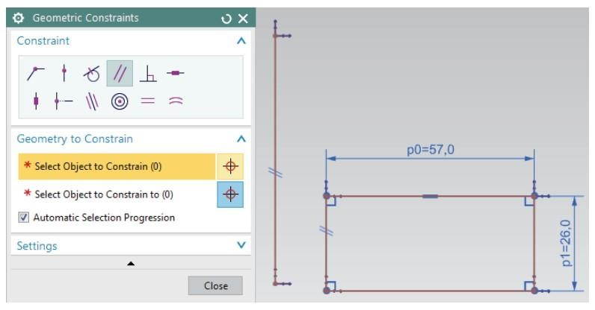

**2.12 DISPLAY SKETCH CONSTRAINTS:**

Clicking this icon will show all the options pertaining to the entities in that particular sketch in white.

**2.13 SHOW/REMOVE CONSTRAINTS:**

This window lists all the constraints and types of constraints pertaining to any entity selected. You can delete any of the listed constraints or change the sequence of the constraints.

The number of degrees of freedom that are not constrained are displayed in the Status Line. All these should be removed by applying the constraints to follow a disciplined modelling.

**3.THREE DIMENSIONAL MODELING**

**3.1 THREE DIMENSIONAL MODELING**

Commonly Features can be classified as following

* Body: A class of objects containing solids and sheets - Solid Body: A collection of faces and edges that enclose a volume
* Sheet Body: A collection of one or more faces that do not enclose a volume
* Face: A region on the outside of a body enclosed by edges

**3.2 TYPES OF FEATURES:**

There are six types of Form Features: Primitives, Reference features, swept features, remove features, Extract features, and User-defined features. Similar to previous versions, NX 10 stores all the Form Features under the Insert menu option. The form features are also available in the Form Features Toolbar.

* Click Insert on the Menu
* As you can see, the marked menus in the figure on the right side contain the commands of Form Features. The Form Feature icons are grouped in the Home Toolbar as shown below. You can choose the icons that you use frequently.
* Click on the drop down arrow in Home Toolbar
* Choose Feature Group

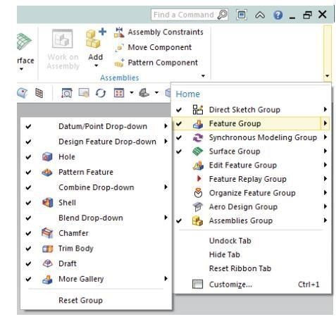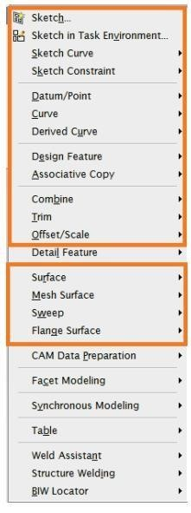

**3.3 PRIMITIVES:**

They let you create solid bodies in the form of generic building shapes. Primitives include:

• Block

* Cylinder
* Cone
* Sphere

**3.4 DATUM AXIS:**

In this part, you are going to create a Datum Axis. A Datum Axis is a reference feature that can be used to create Datum Planes, Revolved Features, Extruded Bodies, etc. It can be created either relative to another object or as a fixed axis (i.e., not referencing, and not constrained by other geometric objects).

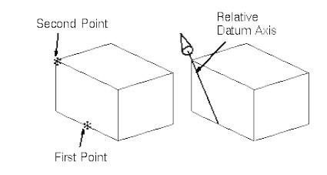

Choose Insert →Datum/Point →Datum Axis

The Datum Axis dialog can also be opened by clicking the icon as shown in the figure below from the Feature toolbar.

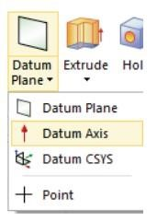

The Datum Axis dialog can also be opened by clicking the icon as shown in the figure below from the Feature toolbar.

**3.5 GENERAL HOLE:**

This option lets you create Simple, Counter bored, Countersunk and Tapered holes in solid bodies.

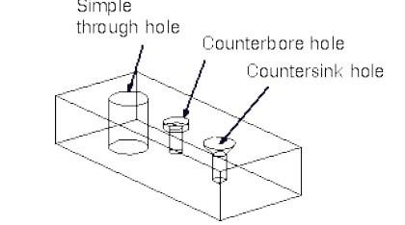

**3.6 FEATURE OPERATIONS:**

Feature Operations are performed on the basic Form Features to smooth corners, create tapers, make threads, do instancing and unite or subtract certain solids from other solids. Some of the Feature Operations are explained below.

**3.7 EDGE BLEND:**

An Edge Blend is a radius blend that is tangent to the blended faces. This feature modifies a solid body by rounding selected edges. This command can be found under Insert →Detail Feature →Edge Blend. You can also click on its icon in the Feature Group. You need to select the edges to be blended and define the Radius of the Blend as shown below.

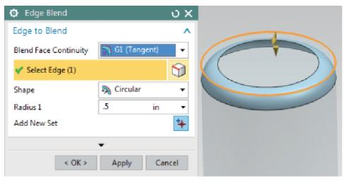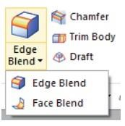

**3.8 CHAMFER:**

The Chamfer Function operates very similarly to the Blend Function by adding or subtracting material relative to whether the edge is an outside chamfer or an inside chamfer. This command can be found under Insert →Detail Feature →Chamfer.

You can also click on its icon in the Feature Group. You need to select the edges to be chamfered and define the Distance of the Chamfer as shown below.

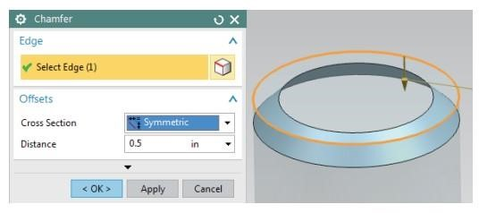

**3.9 THREAD:**

Threads can only be created on cylindrical faces. The Thread Function lets you create Symbolic or Detailed threads (on solid bodies) that are right or left handed, external or internal, on cylindrical faces such as Holes, Bosses, or Cylinders. It also lets you select the method of creating the threads such as cut, rolled, milled or ground. You can create different types of threads such as metric, unified, acme and so on. To use this command, go to Insert →Design Feature →Thread. An example of a Detailed Thread is shown below.

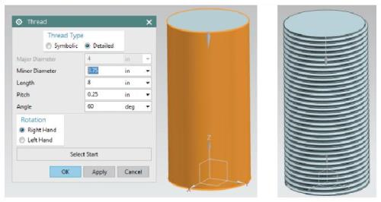

For Threaded Holes, it is recommended to use the Threaded Hole command instead of the Thread command: Insert →Design Feature →Hole.

**3.10 MIRROR:**

Mirror is a type of Associative Copy in which a solid body is created by mirroring the body with respect to a plane. To use this command, go to Insert →Associative Copy →Mirror Feature or click on its icon in the Feature Group. An example is shown below.

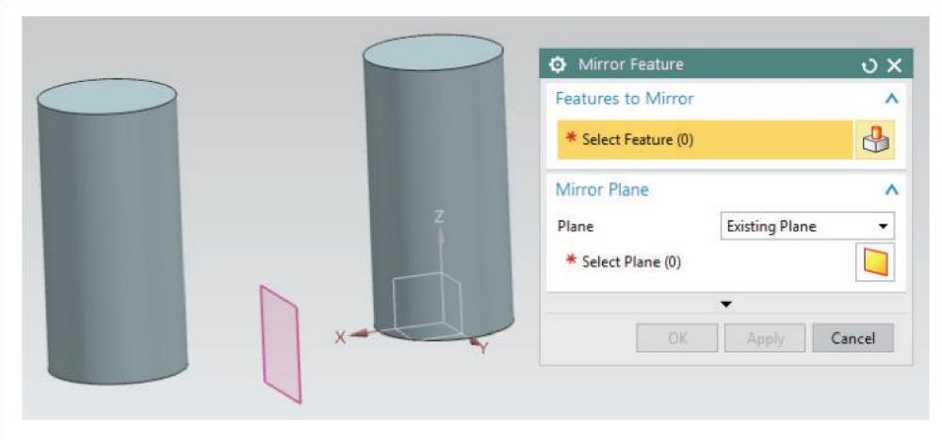

**3.11 PATTERN:**

A Design Feature or a Detail Feature can be made into dependent copies in the form of an Array. It can be Linear, Circular, Polygon, Spiral, etc. This particularly helpful feature saves plenty of time and modelling when you have similar features. For example, threads of a gear or holes on a mounting plate, etc. This command can be found under Insert →Associative Copy →Pattern Feature. You can also click on its icon in the Feature Group. An example is shown below.

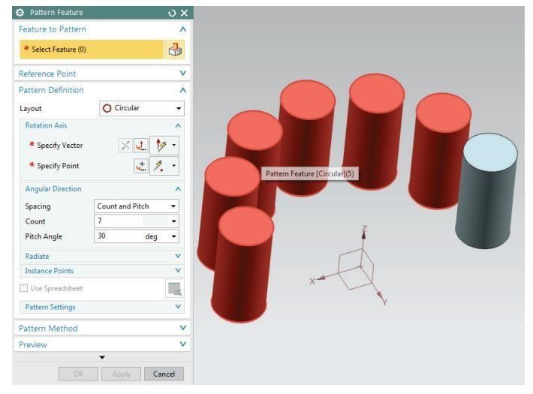

**3.12 BOOLEAN OPERATIONS:**

There are three types of Boolean Operations: Unite, Subtract, and Intersect. These options can be used when two or more solid bodies share the same model space in the part file. To use this command, go to Insert → Combine or click on their icons in the Feature Group. Consider two solids given: a block and a cylinder are next to each other as shown below.

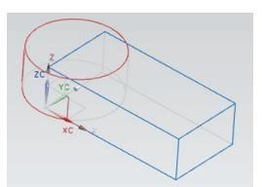

**3.13 UNITE**:

The unite command adds the Tool body with the Target body. For the above example, the output will be as follows if Unite option is used.

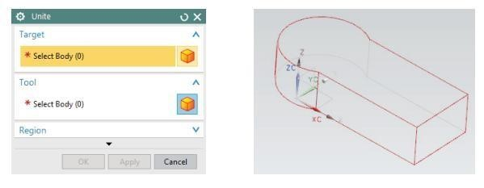

**3.14 SUBTRACT:**

When using the subtract option, the Tool Body is subtracted from the Target Body. The following would be the output if the Block is used as the Target and the Cylinder as the Tool.

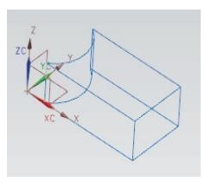

**3.15 INTERSECT:**

This command leaves the volume that is common to both the Target Body and the Tool Body. The output is shown below.

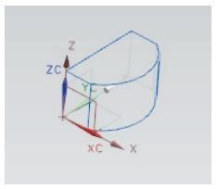

**3.16 MOVE:**

If you want to Move an object with respect to a fixed entity,

* Click on Edit →Move Object

You can select the type of motion from the Motion drop-down menu. The default option is Dynamic. With this you can move the object in any direction. There are several other ways of moving the object.

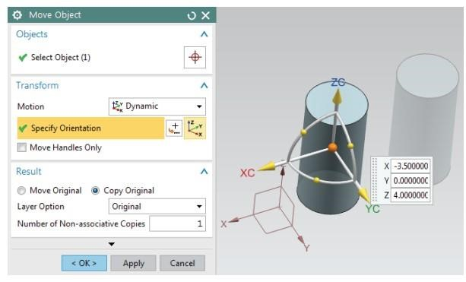

**4.ASSEMBLY MODELING:**

**4.1 ASSEMBLY NAVIGATOR:**

The Assembly Navigator is located on top of the Part Navigator in the Resource Bar on the left of the screen. The navigator shows you various things that form the assembly, including part hierarchy, the part name, information regarding the part such as whether the part is read only, the position, which lets you know whether the part is constrained using assembly constraints or mating condition, and the reference set. Following is a list of interpretation of the Position of the components.

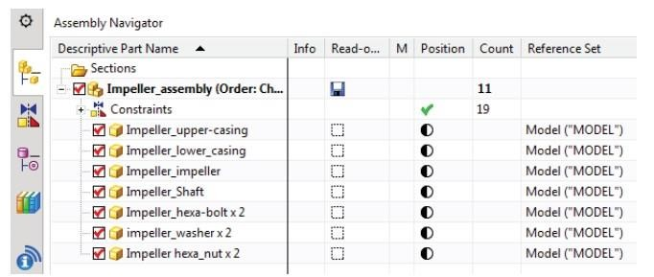

**4.2 MATING CONSTRAINTS:**

After the Component Objects are added to the assembly part file, each Component Object is mated with the existing objects. By assigning the mating conditions on components of an assembly, you establish positional relationships, or constraints, among those components. A mating condition is made up of one or more mating constraints. There are different mating constraints as explained below:

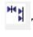 **Touch/Align**: Planar objects selected to align will be coplanar but the normal to the planes will point in the same direction. Centrelines of cylindrical objects will be in line with each other.

**Concentric:** Constrains circular or elliptical edges of two components so the centres are coincident and the planes of the edges are coplanar.

**Distance**: This establishes a +/- distance (offset) value between two objects.

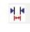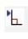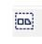

**Parallel**: Objects selected will be parallel to each other.

**Perpendicular:** Objects selected will be perpendicular to each other.

**Bond:** Creates a weld and welds components together to move as single object.

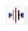 **Centre:** Objects will be centred between other objects, i.e. locating a cylinder along a slot and centring the cylinder in the slot.

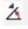**Angle**: This fixes a constant angle between the two object entities chosen on the components to be assembled.

**5. PROJECT**

**5.1 AIM**: To construct a **Robotic Arm Assembly** using NX software.

**5.2 TOOLS USED FOR SKETCHING: -**

1. Sketch

* Rectangle
* Line
* Circle
* Arc
* Quick trim
* Mirror curve

1. Datum plane
2. Extrude
3. Edge blend
4. Thread
5. Sketch constraints
6. Chamfer
7. Finish sketch

**5.3 TOOLS USED FOR ASSEMBLY: -**

1. Add
2. Assembly constraints

* Touch align
* Concentric
* Distance
* Fix
* Parallel

1. Move component

**5.4 TOOLS USED FOR DRAFTING: -**

1. A3 – size
2. View creation wizard

* Part
* Options
* Orientation

Top

Front

Right

Isometric

1. Dimensions
   * + Rapid dimensions
     + Linear dimensions
     + Radial
     + Angular

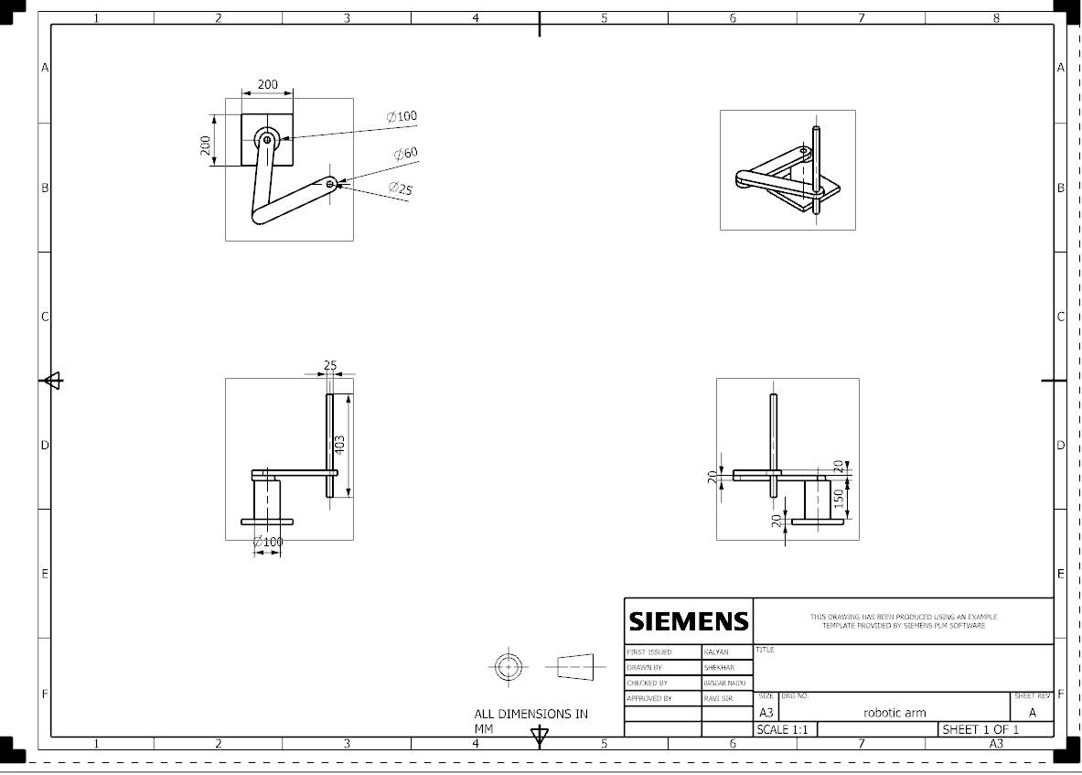

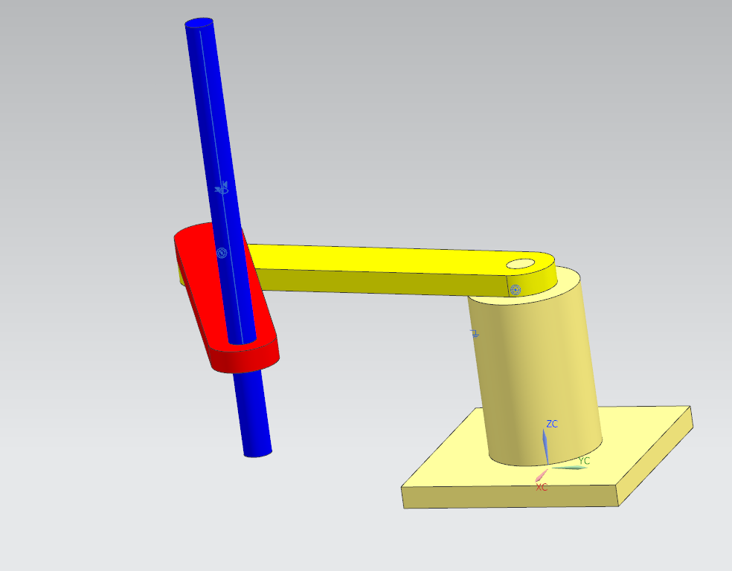

**5.5 MODEL 1:**

Steps to create model 1:

**Step 1:** Take a new file and select model and name it as model 1 and choose the location and click ok.

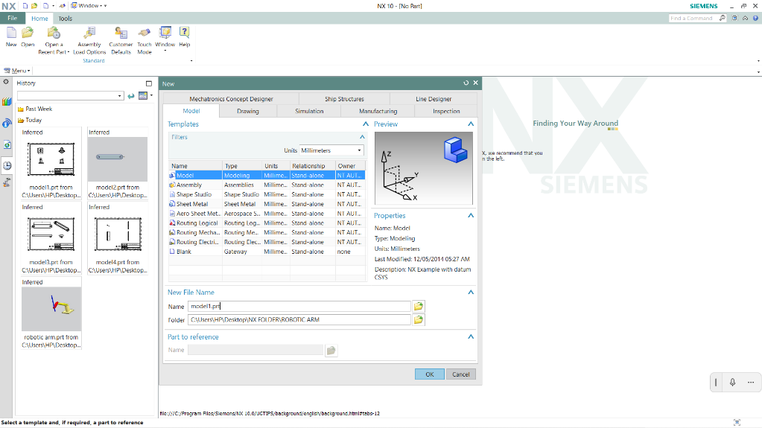

**Step 2:** Now take a rectangle200*200 and extrude it to the 20mm

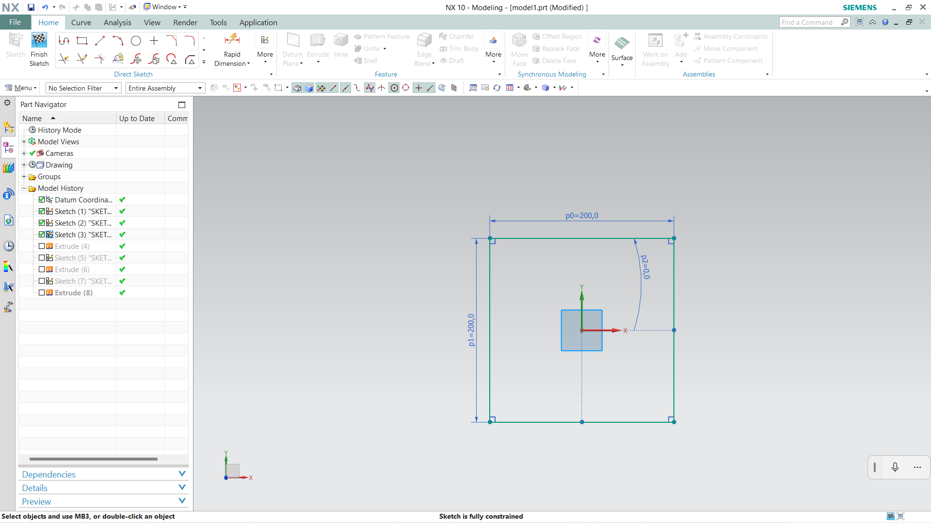

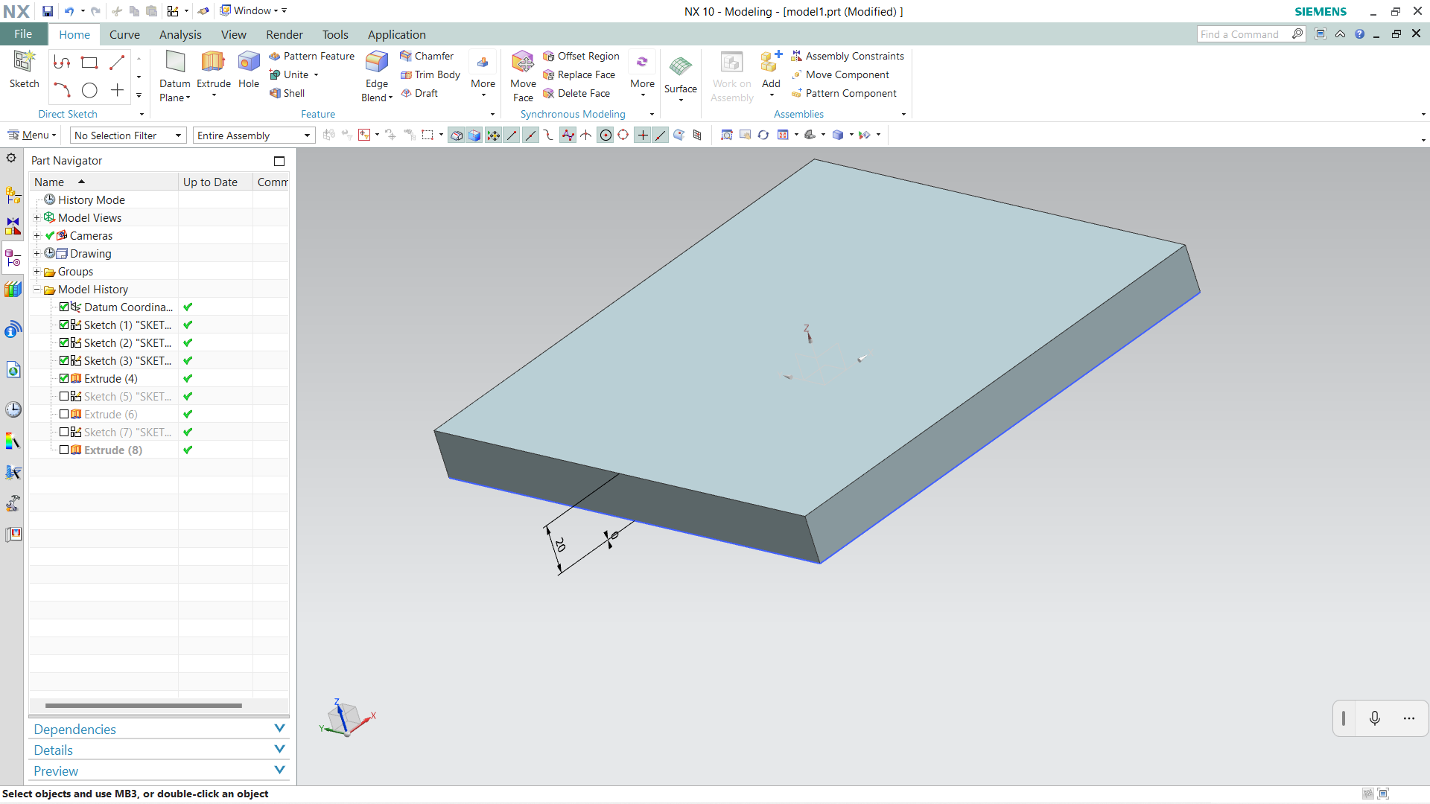

**Step 3:** Take a circle with diameter of 100mm on the centre of rectangle and extrude it to the 150mm

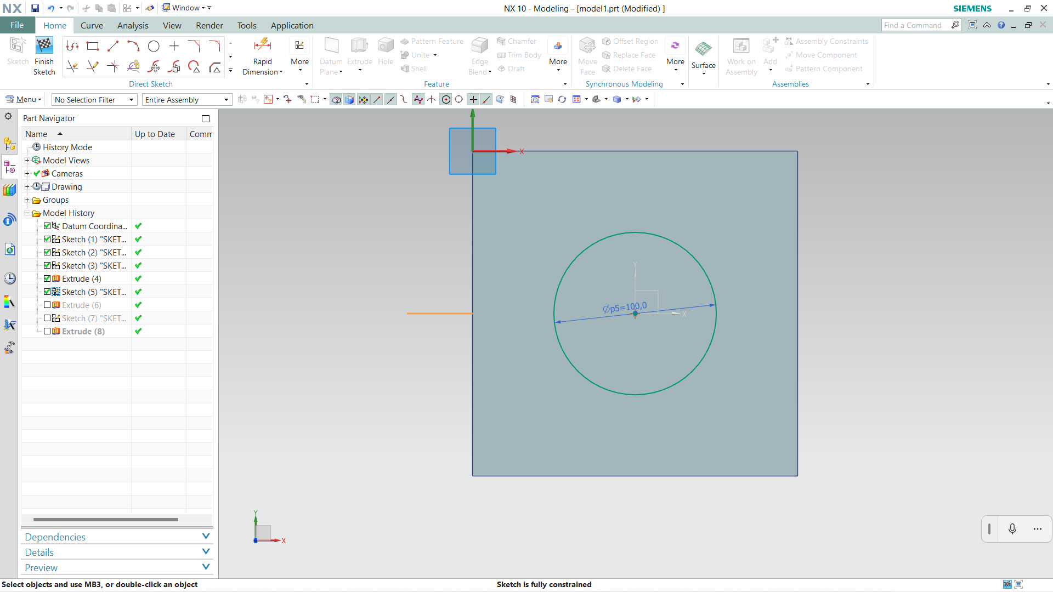

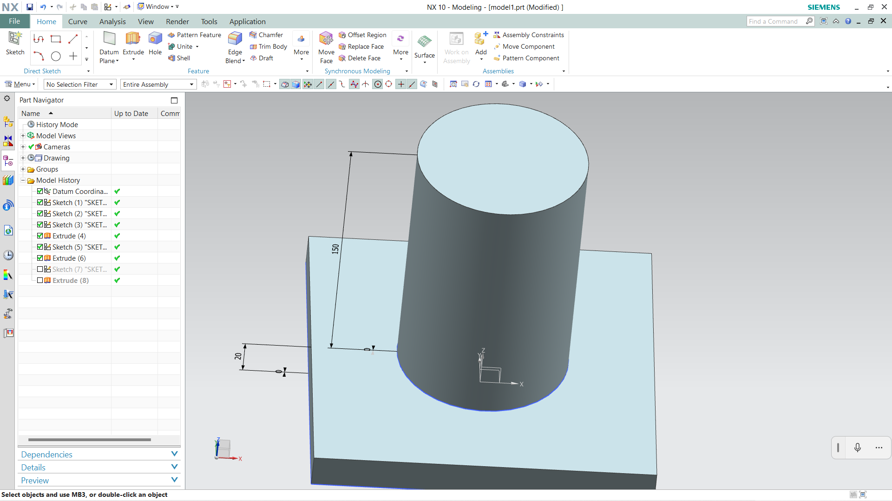

**Step 4:** Now take another circle on the 100mm circle with diameter of 25mm with 20mm depth.

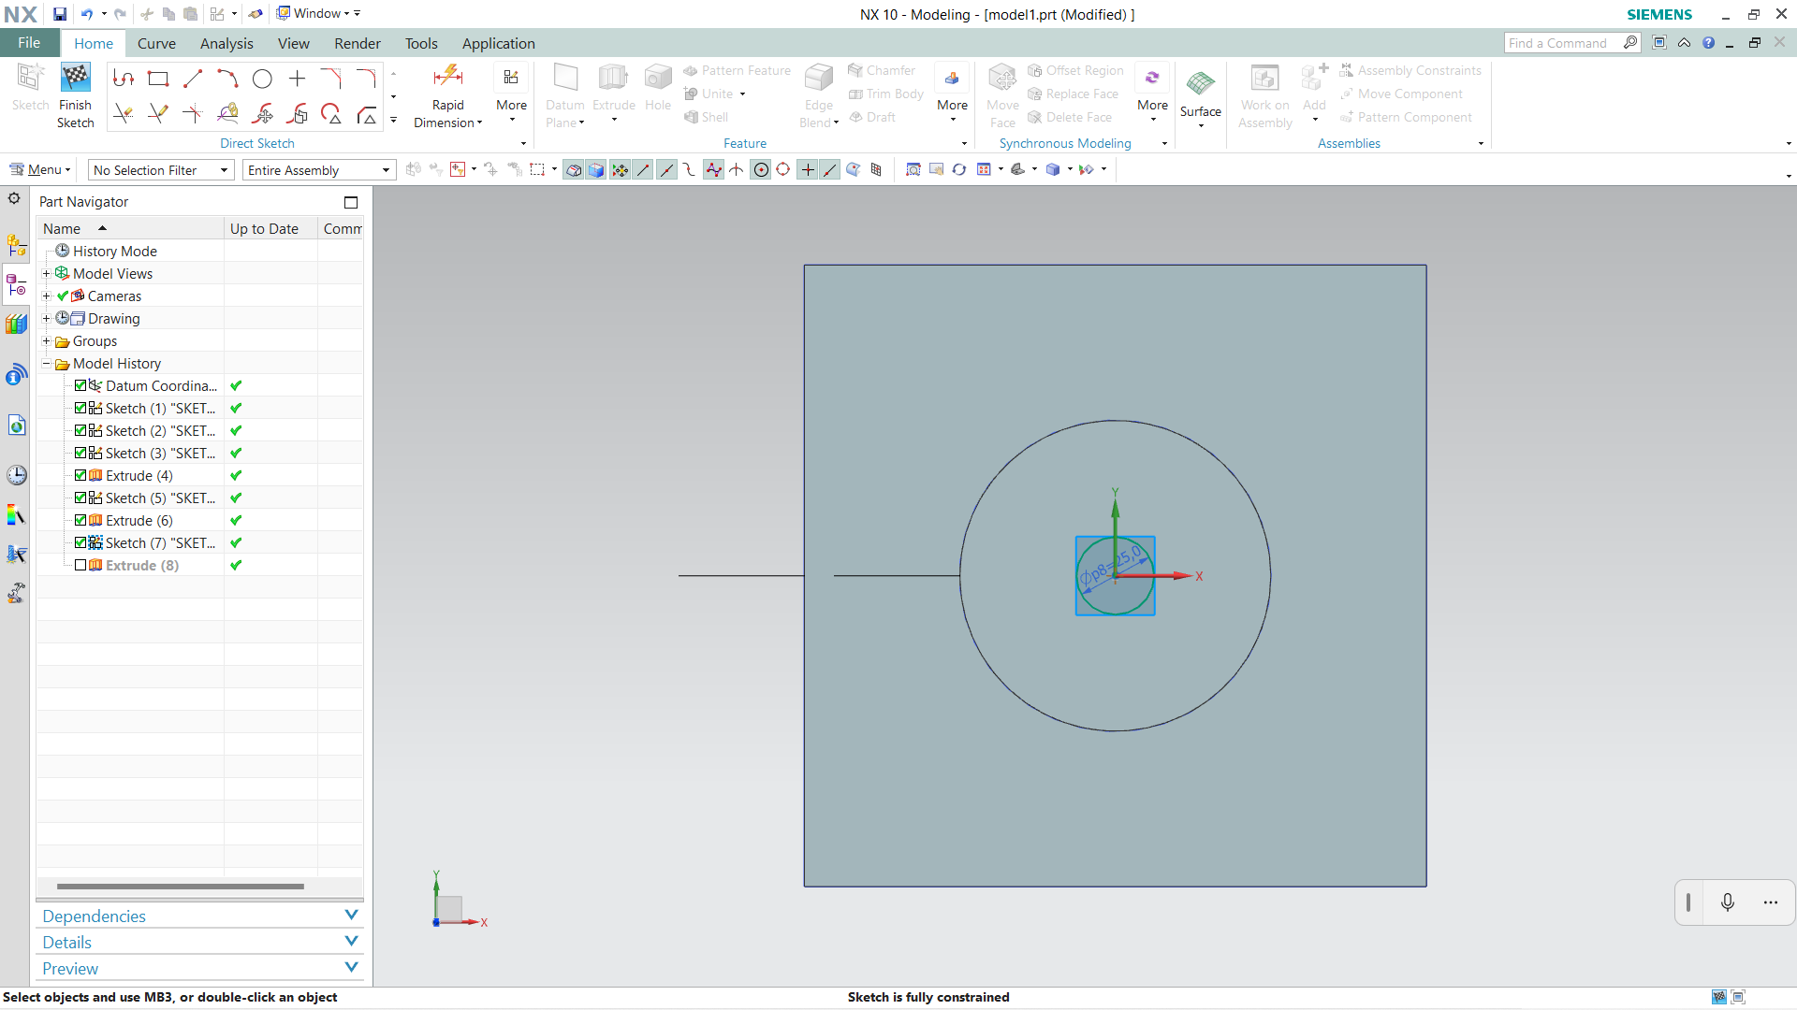

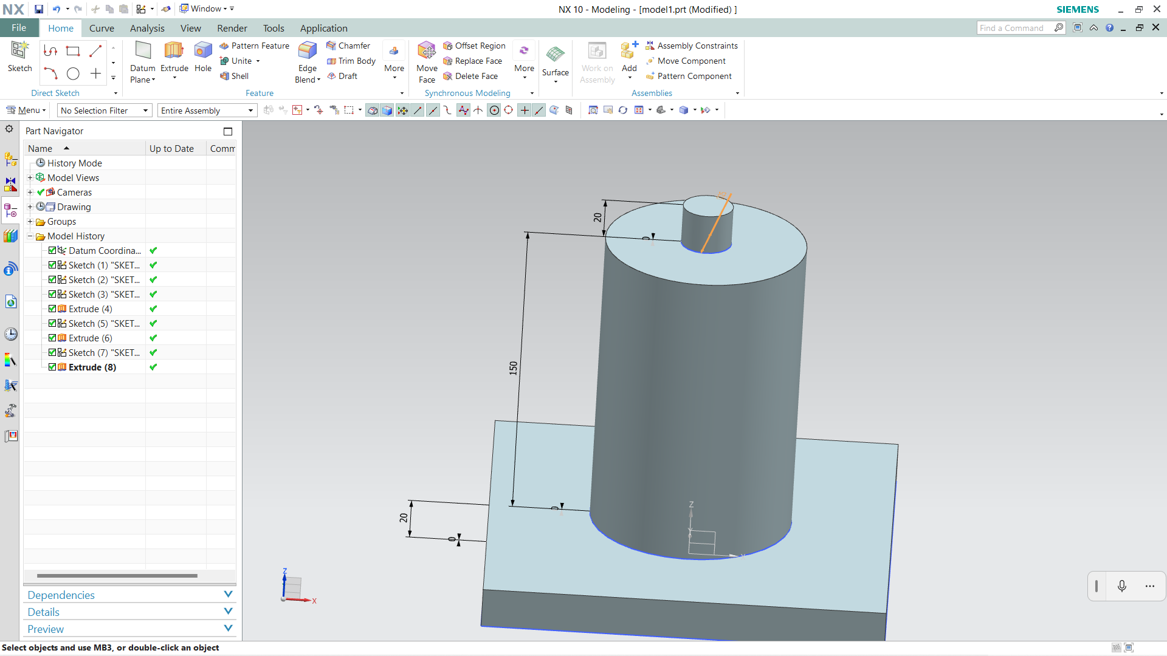

**Step 5:** Save the model

**5.6 MODEL 2:**

Steps to create model 2:

**Step 1:** Take a new file and select model and name it as model 2 and choose the location and click ok.



**Step 2:** Take a rectangle 300*60 and extrude it to the 20mm.

**Step 3:** Draw a arc at both ends of a circle with radius of 30mm and extrude it to the 20mm

**Step 4:** Now take circles on the rectangle with distance of 300mm on the rectangle with diameter of 25mm of circles and kept those as holes on rectangle by extrude.

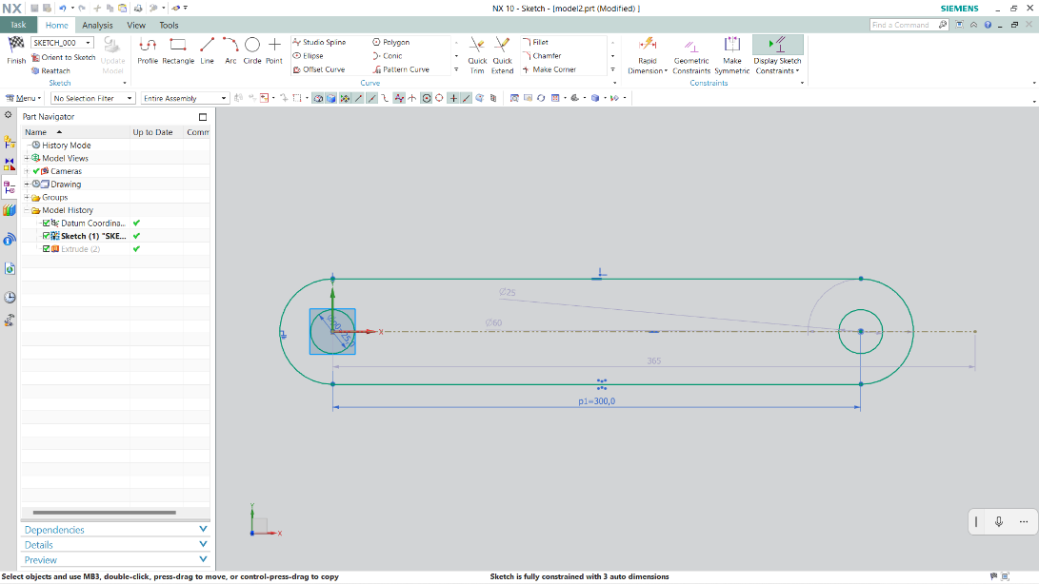

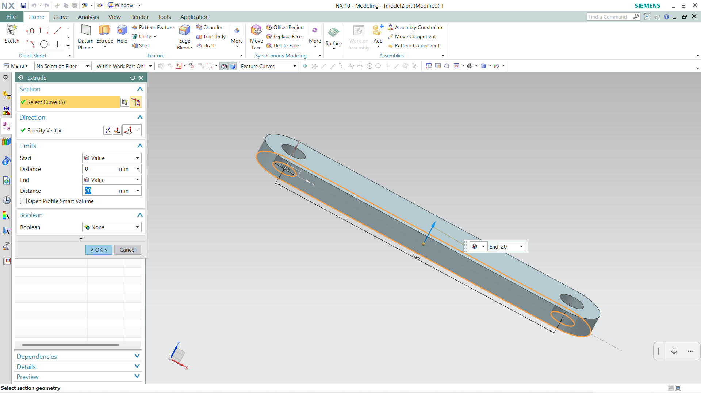

**Step 5:** Save the model

**5.7 MODEL 3:**

Steps to create model 3:

**Step 1:** Take a new file and select model and name it as model 3 and choose the location and click ok.



**Step 2:** Take a rectangle 300*60 and extrude it to the 20mm.

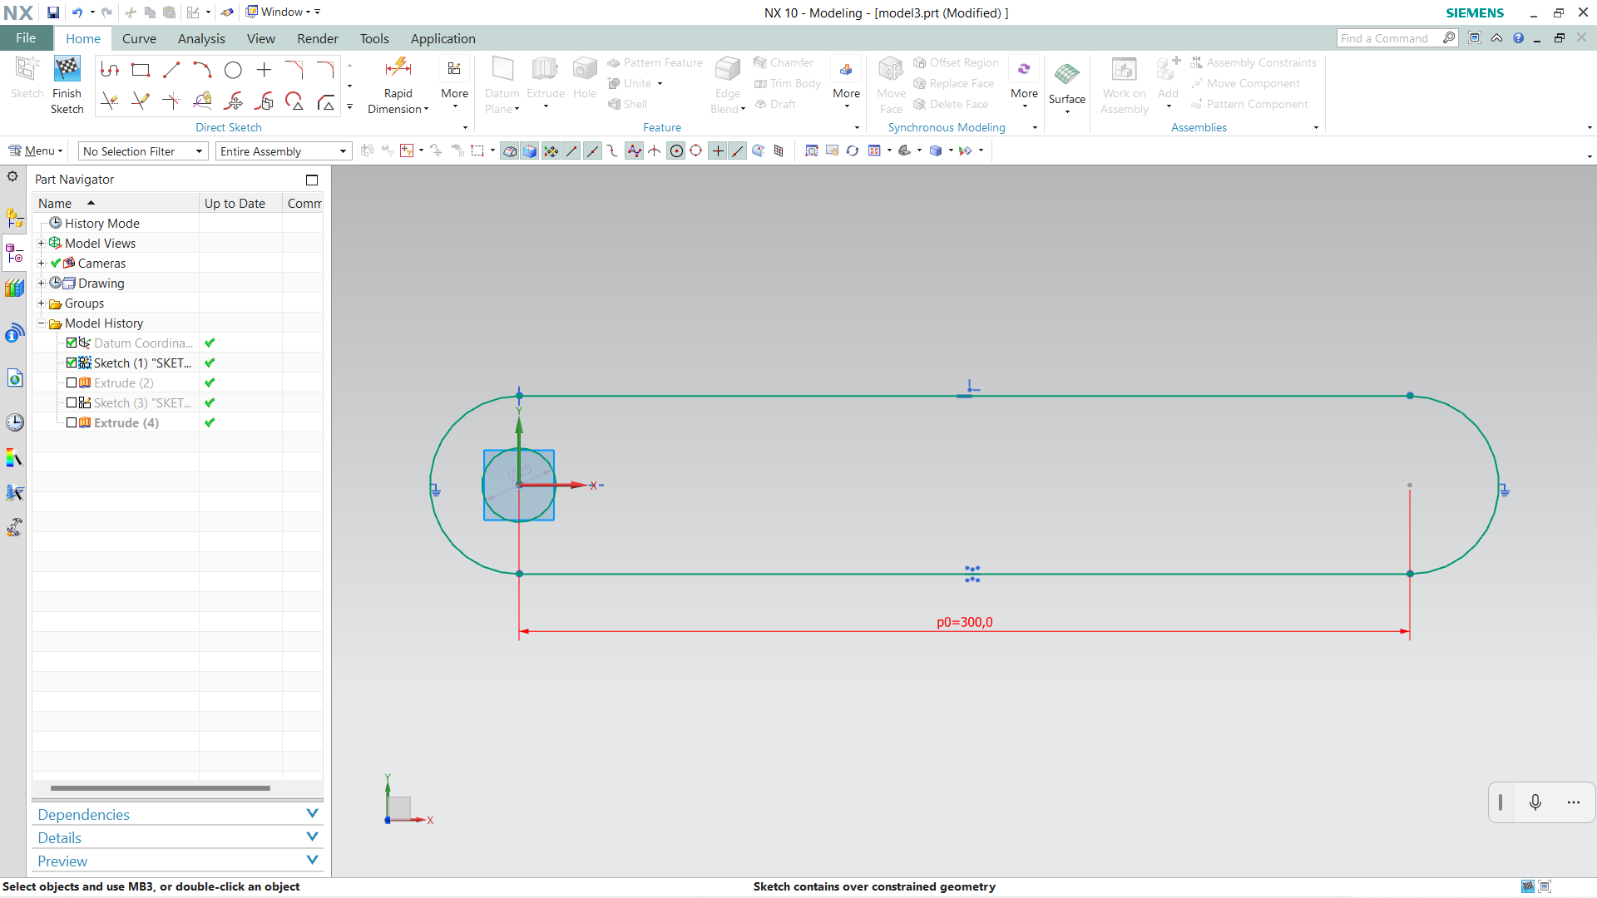

**Step 3:** Draw a arc at both ends of a circle with radius of 30mm and extrude it to the 20mm

**Step 4:** Now take circles on the rectangle with distance of 300mm on the rectangle with diameter of 25mm of circle at one end and kept that as hole on rectangle by extrude-> subtraction. On the other end extrude it to the 20mm.

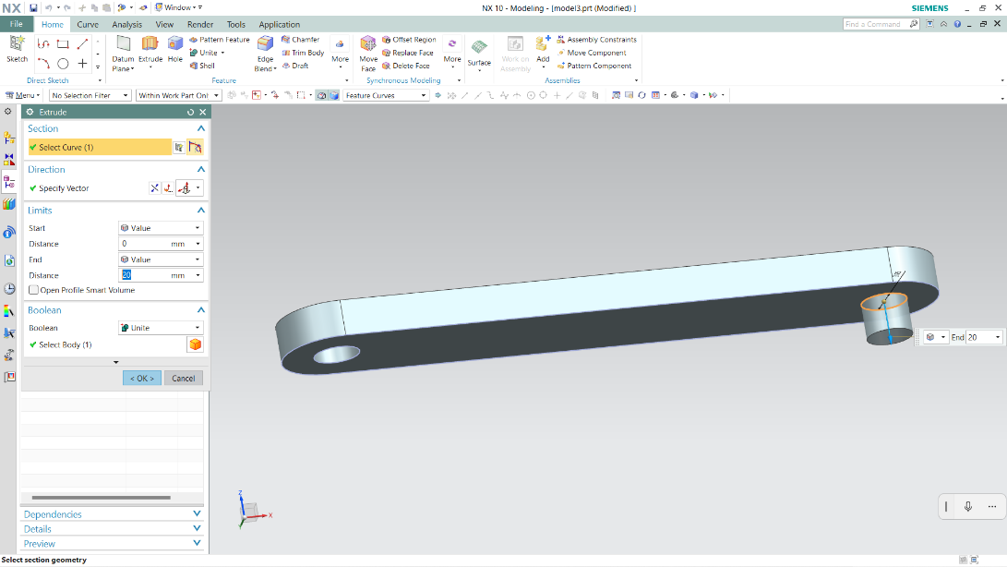

**Step 5:** Save the model

**5.7 MODEL 4:**

Steps to create model 4:

**Step 1:** Take a new file and select model and name it as model 4 and choose the location and click ok.



**Step 2:** Draw a circle with radius of 12.5mm and extrude it to the 400mm.

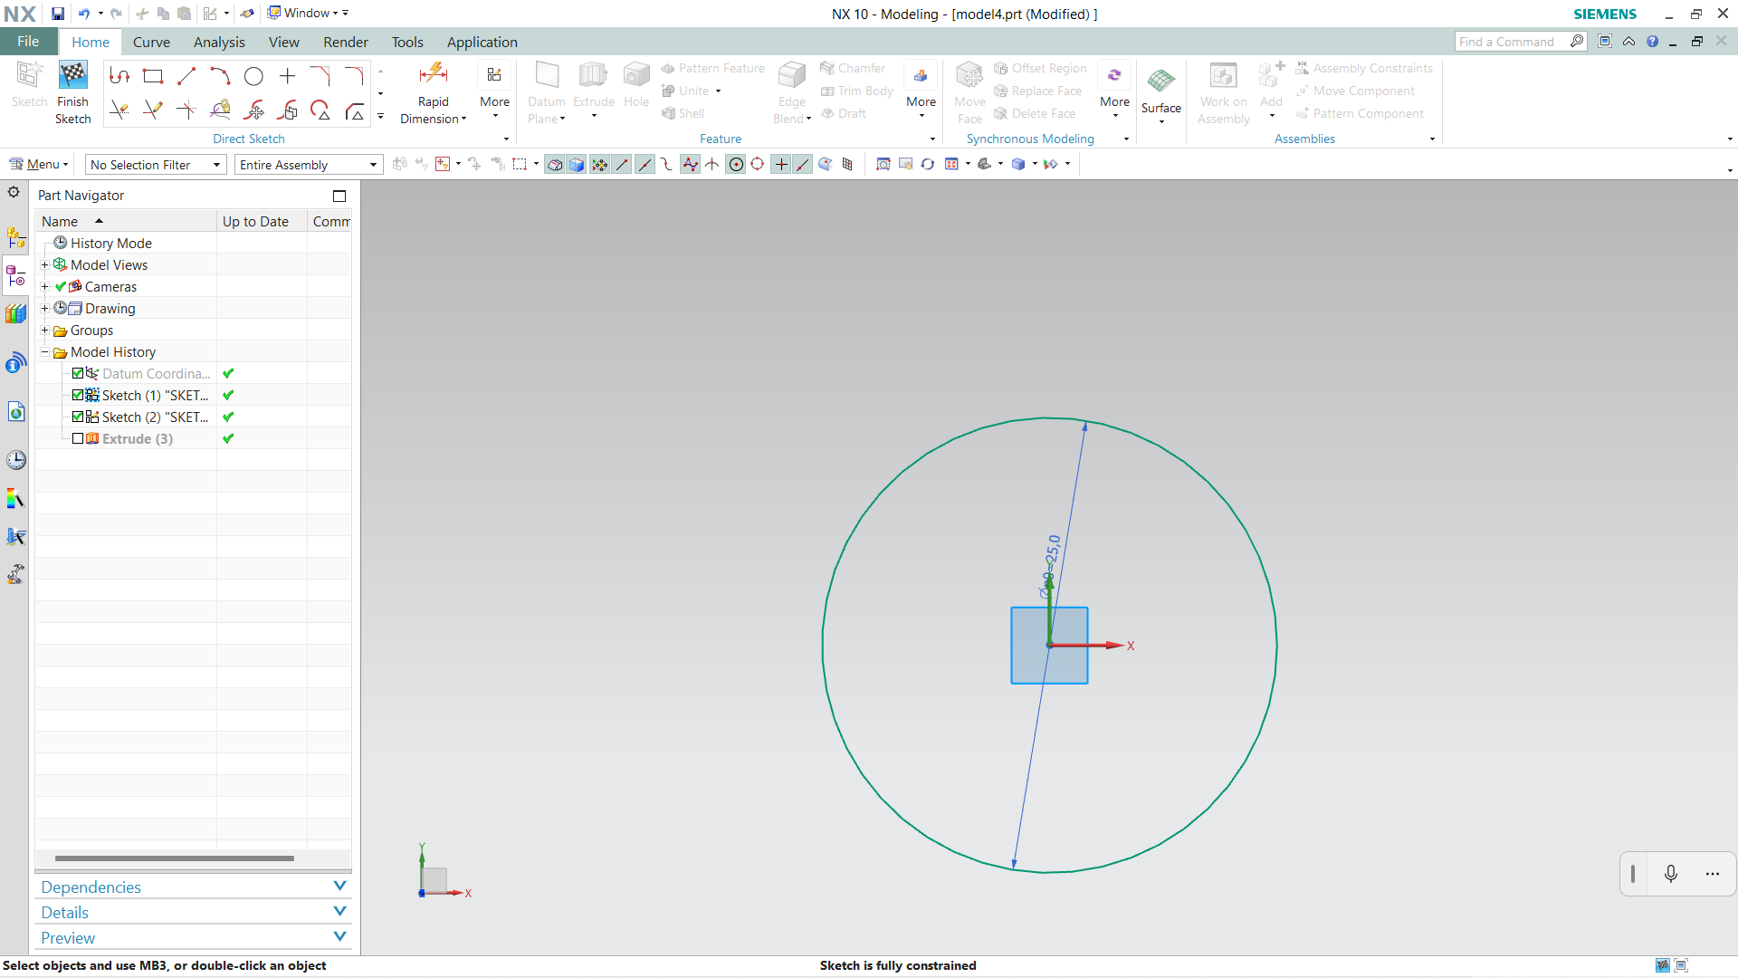

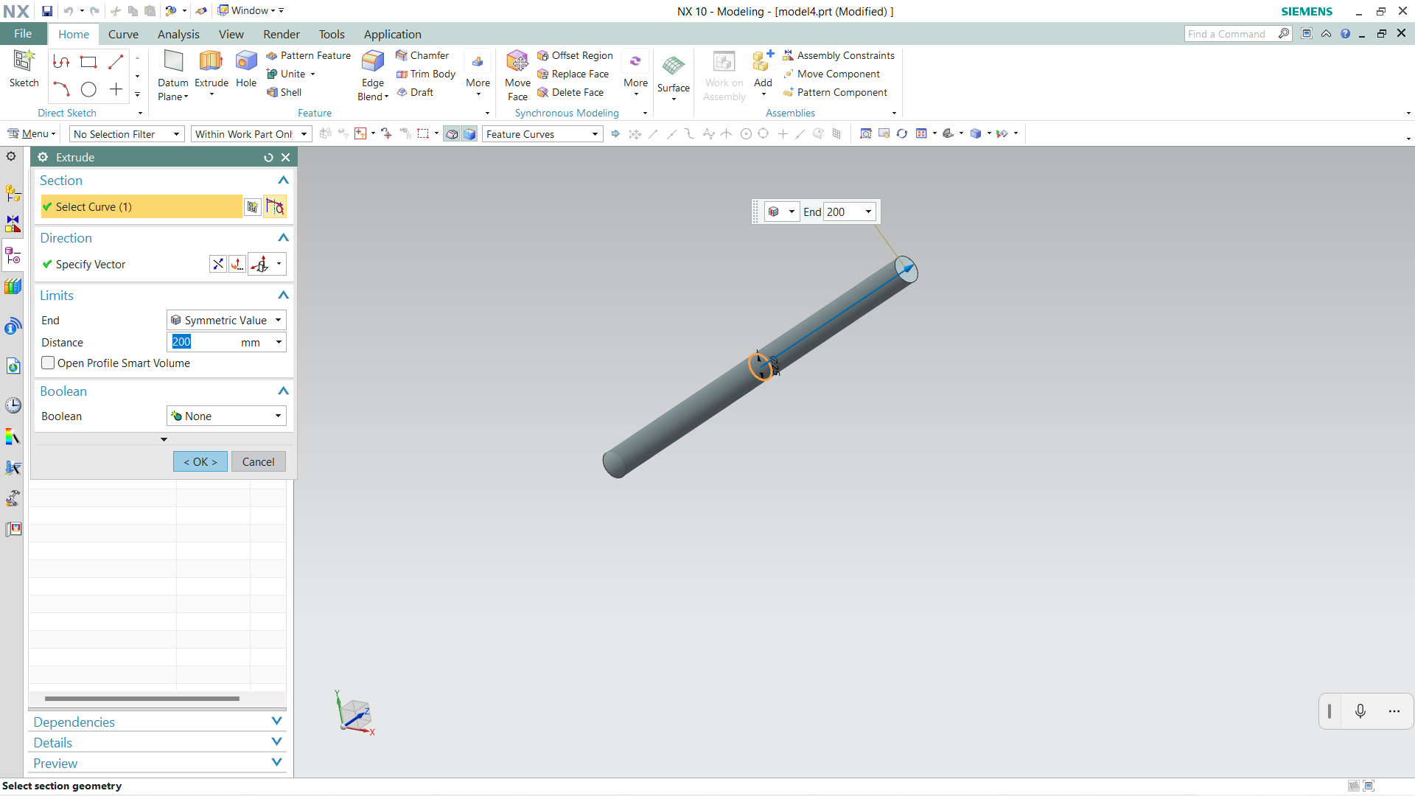

**Step 3:** Save the model

**5.8 ASSEMBLE THE COMPONENTS:**

Steps for making the assembly of components:

**Step 1:** Take a new file and select Assemblies and name it as Robotic arm and choose the location and click ok.

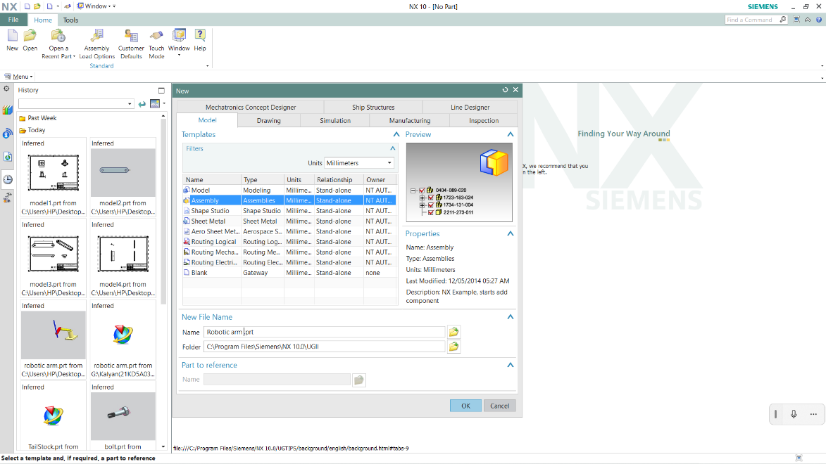

**Step 2:** Set model 1 component as base and fix it.

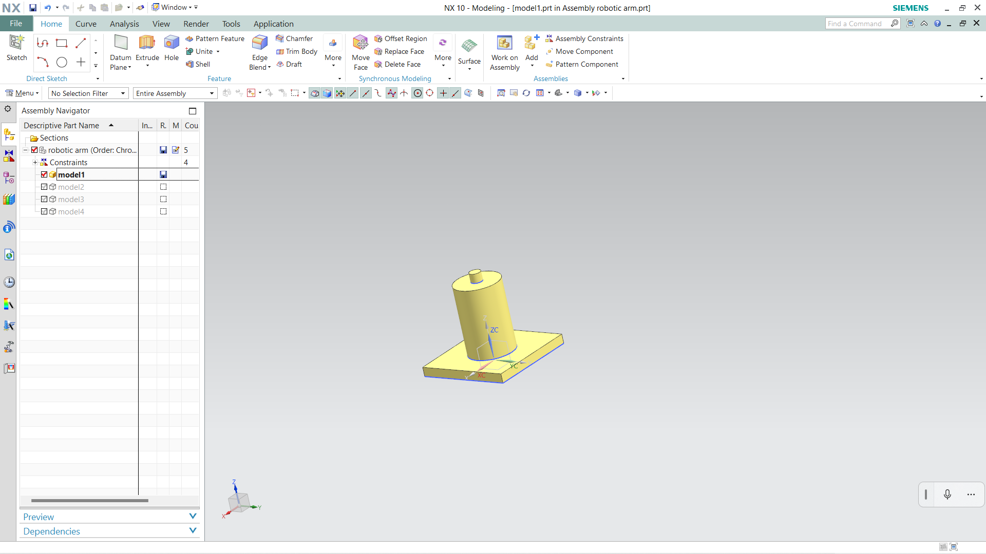

**Step 3:** Add model 2 component and concentric one end of the hole of the model 2 to the extrude part of the model 1 which is 25mm.

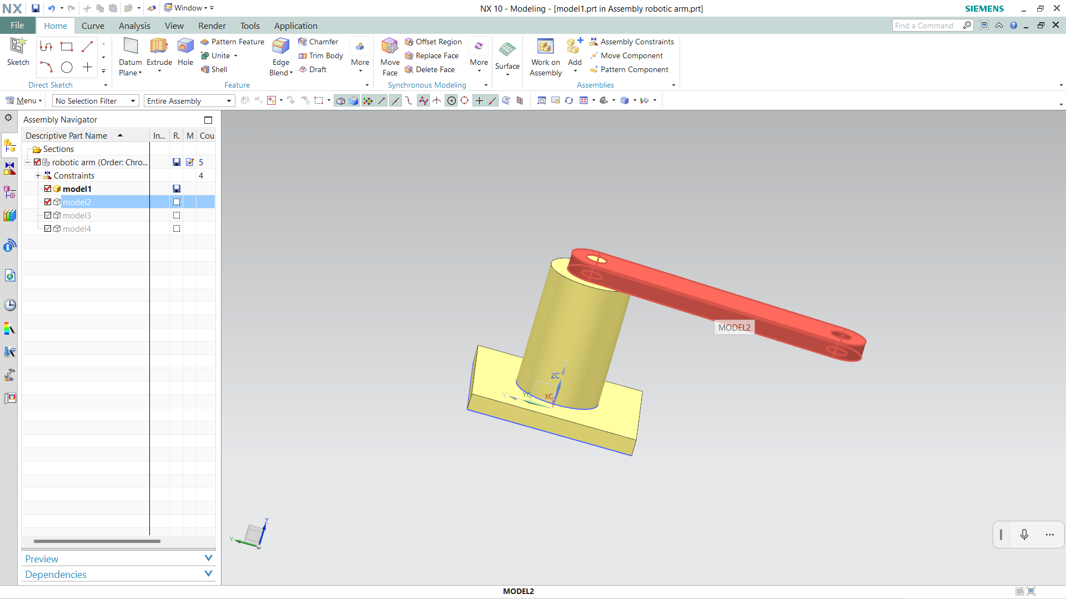

**Step 4:** Add model 3 and concentric the extruded part of model 3 to the model 2

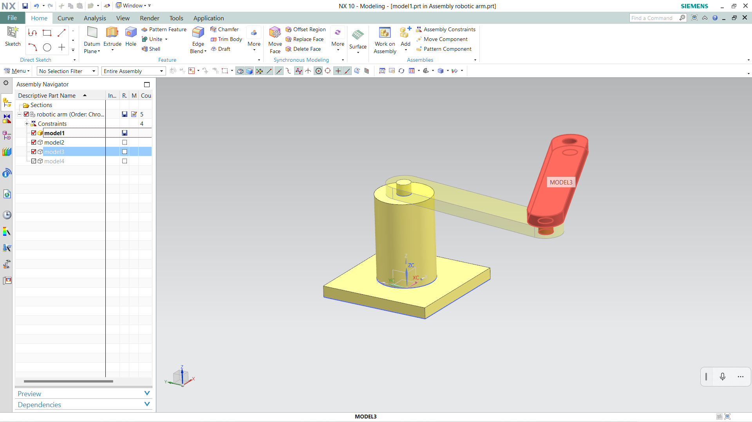

**Step 5:** Add model 4 and use the touch aline and concentric to insert into the hole of the model 3.

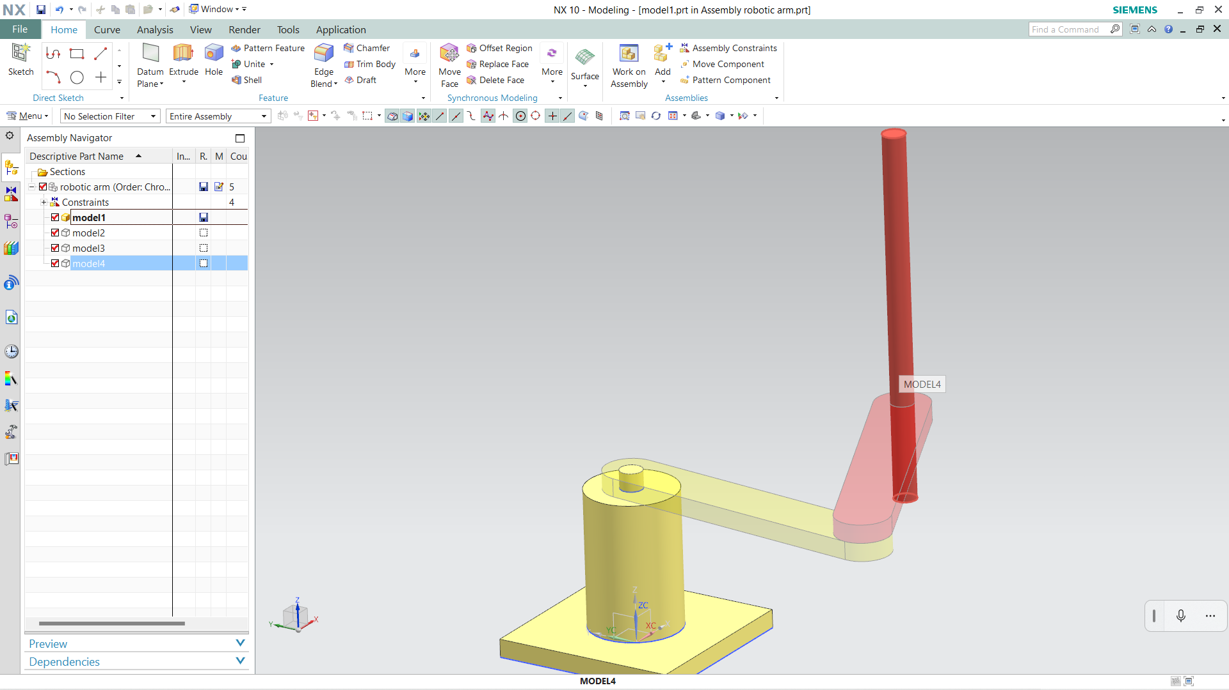

**Step 6:** Save the model

**5.9 CONCLUSION:** Assembly of Robotic Arm was successfully designed by using NX 10 software.